**Module 22 Second Segment Project Deliverable**

tart Assignment

Congratulations on making it past the halfway point of the final project! You’ve completed two segments and have one more to go.

Now is the time to submit your work to your instructor and get the credit that you’ve earned. And, be sure to carefully review any feedback that you receive from your instructor. Doing so will help you both improve and adjust your approach, if necessary.

**Requirements for Segment 2**

Segment 2 is worth 32% of your overall grade for the Final Project.

Before you submit the Segment 2 deliverable, make sure that you have all the pieces in place by reviewing the requirements.

**Content (80 points)**

In this segment, the project deliverable includes the following:

* A detailed README.md file that includes the project status, images, descriptions, and results (20 points)
  + C_Group’s “latest and great ” README Includes a Project Workbook, which, we are also utilizing to create our PowerPoint Presentation.
* At least eight total commits per team member (20 points)
* A machine learning model, including a confusion matrix and accuracy score (20 points)
* Database that stores data for the project with at least two tables or collections (20 points)
  + We have screenshots of the Database -structure, details about each DataBase and its structure

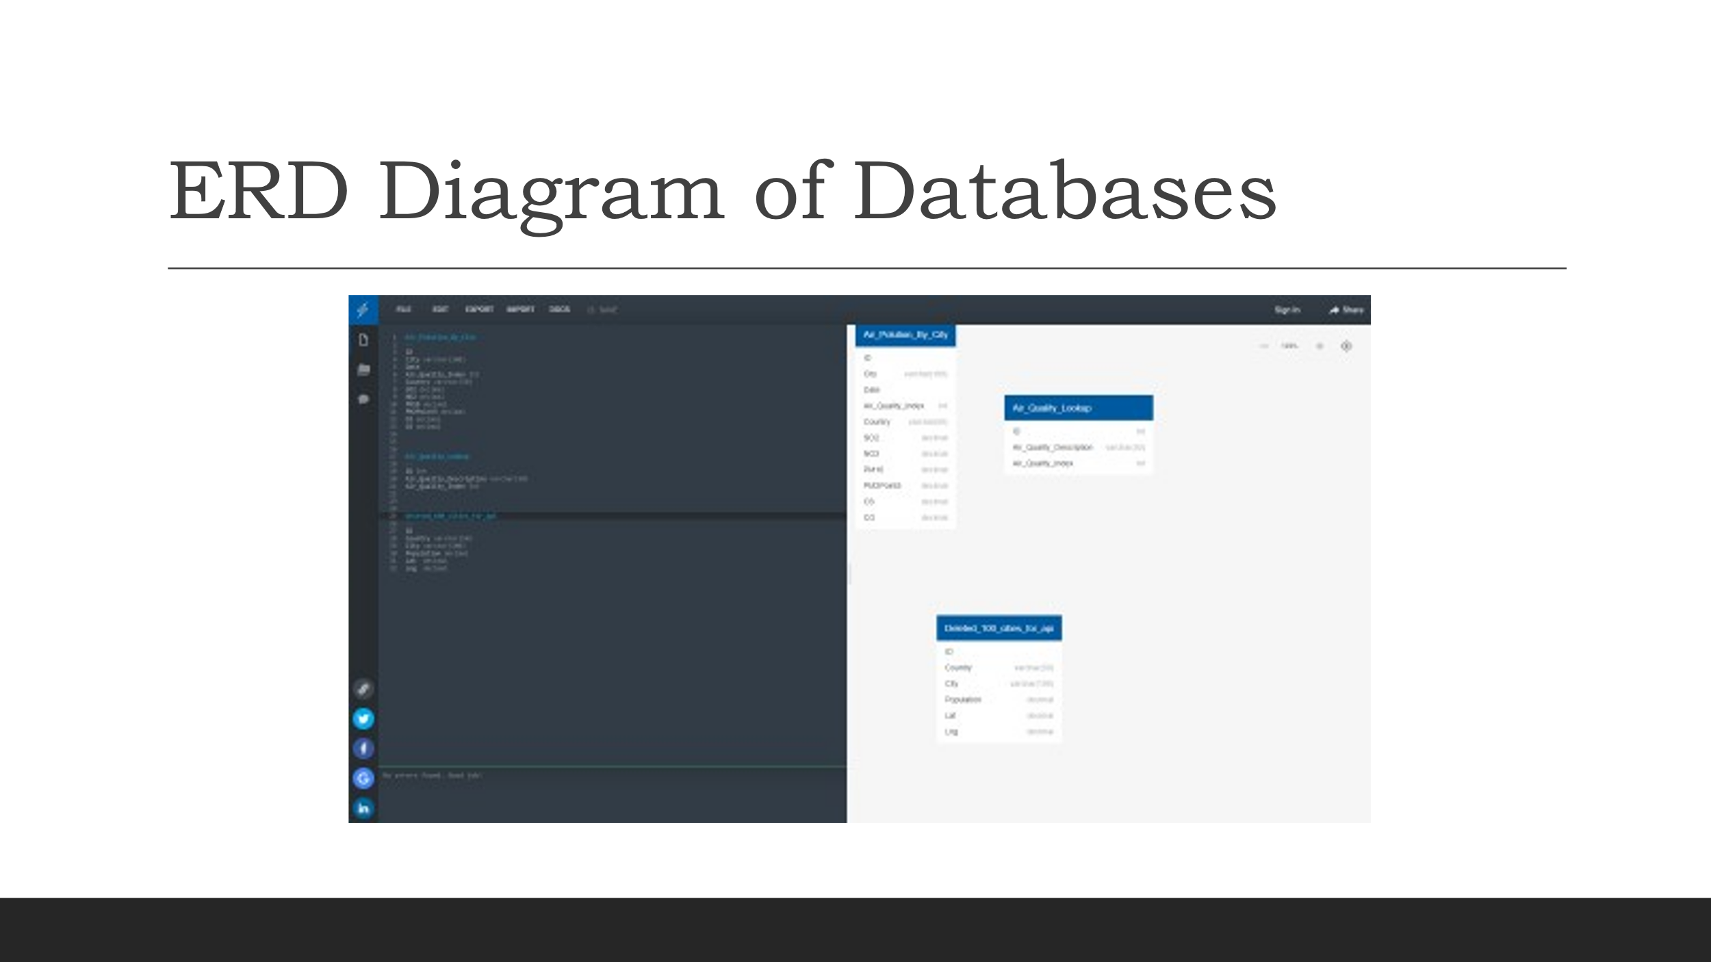

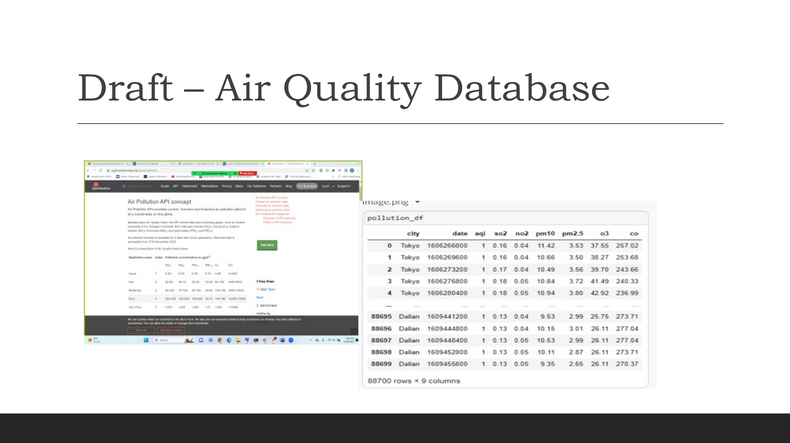

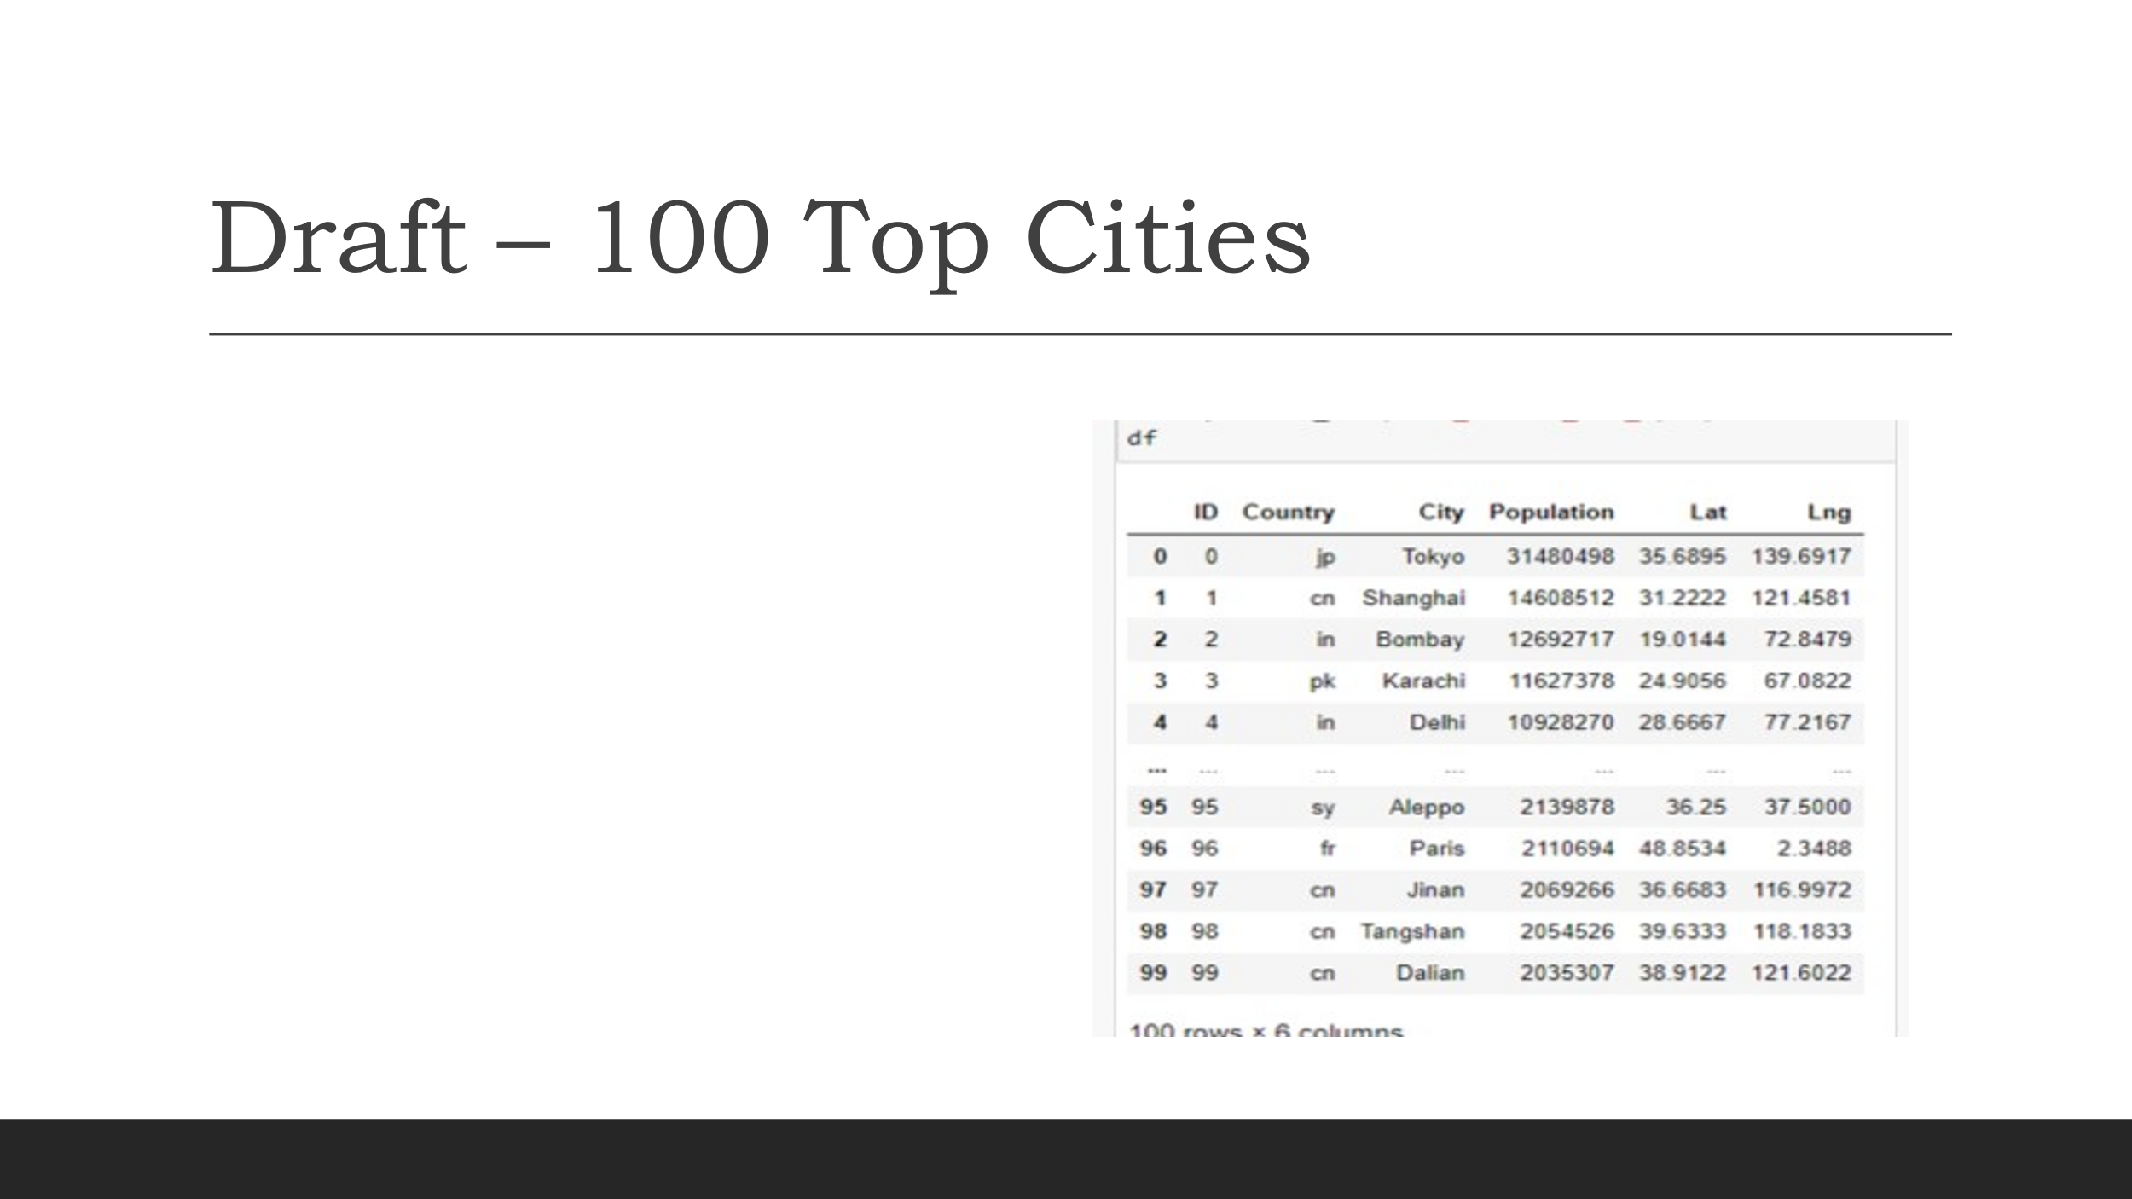



Notice that a machine learning model is the main addition to the project deliverable for this segment. And, keep in mind that Segment 3 will require an interactive dashboard. If any team members have extra time, the dashboard will offer an excellent area for working ahead.

If time seems too limited to get everything done, remember that no requirements exist regarding the performance of the machine learning model. In fact, it’s perfectly acceptable if early versions of the model don’t work well at all. The goal is to quickly get a model functioning (even if it functions poorly), and then use as much of the remaining time as the team chooses to improve and add to the model.

**Presentation (20 points)**

In this segment, the presentation deliverable should tell a story about your project and include the following:

* The selected topic and the reasoning for that selection (2 points)
  + Review C_Group’s “latest and great ” README file, which includes a Project Workbook, which, we are also utilizing to create our PowerPoint Presentation.
* A description of the data (3 points)
* The questions that the team originally planned to answer with the project (2 points)
* A description of the data exploration phase of the project (5 points) -README File Content
* A description of the analysis phase of the project (5 points) --README File Content
* The technologies, languages, tools, and algorithms that the team used throughout the project (3 points) -README File Content

Keep in mind that this presentation will be given to your peers—but will also exist in your README.md file for potential employers to observe. Use as little text as possible, and focus on communicating only the most essential information. Make the presentation enjoyable to both give and receive! You’ll have more time in the next segment to polish the slide deck and the dashboard. But, the team can set itself up for success by focusing and trimming the content during this segment.

**IMPORTANT**

Remember that each team member, regardless of their role, needs to submit all the pieces of the deliverable for each segment.

!